Smart Home Automation System

Mr V Veeresh, Associate. Professor
CSE(IoT)
ACE Engineering College
Hyderabad,India
vveeresh1244@gmail.com
Bandari tejasri,Student
CSE(IoT)
ACE Engineering College
Hyderabad,India
bandaritejasri92@gmail.com
Kaluuakolanu Meghanath raji,Student
CSE(IoT)
ACE ENGINEERING COLLEGE
Hyderabad,India
meghanath@gmail.com

Bopparaja preetham, Student
CSE(IoT)
ACE ENGINEERING COLLEGE
Hyderabad, India
bpreetham@gmail.com

Abstract:
Home Automation with Google Assistant, Alexa, and Manual Switches explains a system architecture that uses voice commands via Google Assistant and Alexa platforms to provide remote control and automation of household items. For smooth voice control, the systems interact with Google Assistant and Alexa speech assistants and use the ESP32 micro controller to interface with the devices. Additionally, manual switches are used in this project to offer a practical backup control technique. With the addition of Voice Assistant, Manual Switches, and an ESP32 micro controller, Home Automation becomes even more convenient and adaptable, providing customers with an array of options for interacting and controlling their smart devices. Voice control tools such as Alexa and Google Assistant provide more control over one's home environment for both individuals and those echo-conscious living. It also appeals to simplify everyday activities, which redefines what modern living means by convenience. The major goal of utilizing Google Assistant, Alexa, and manual switches with home automation is to increase control and convenience when it comes to managing the different e systems and appliances in your house. With impairments. They can use voice commands to carry out tasks like turning on and off lights. With the help of this technology, you should be able to engage more freely with your home environment and jobs will be more straightforward and efficient.
Keywords: home automation, google assistant, Alexa, PIR motion sensor, MQTT, ESP32.

I. INTRODUCTION
Smart home automation refers to the integration of technology into residential systems to enhance convenience, security, energy efficiency, and comfort. It allows homeowners to control devices like lights, thermostats, security cameras, and appliances remotely via smartphones or voice assistants. The system uses sensors, Wi-Fi, and cloud computing to automate tasks based on user preferences or environmental conditions. Real-time data from these devices enables continuous monitoring and control. Home automation systems can also improve energy management by optimizing energy usage. This technology offers greater accessibility for individuals with disabilities. It enhances security with smart locks, surveillance, and alert systems. Additionally, automation can help in predictive maintenance by providing alerts on device malfunctions. Smart homes are becoming more common with the rise of IoT (Internet of Things) technology. Real-time project implementation in this area involves designing and deploying interconnected devices that respond to user needs in real time.
II. OBJECTIVES
The primary objective of this project is to develop an integrated home automation system that leverages Google Assistant, Amazon Alexa, and manual switches using the ESP32 microcontroller as the core control unit. This system is designed to provide users with multiple modes of interaction—voice commands and physical switches—allowing for increased flexibility, accessibility, and convenience in managing various household appliances such as lights, fans, and other electrical devices.
The use of voice assistants like Google Assistant and Alexa enables hands-free control, which is especially beneficial for the elderly and individuals with physical impairments, empowering them to independently interact with their environment. At the same time, incorporating manual switches ensures the system remains functional and accessible during internet outages or when voice control is impractical, offering a fail-safe and user-friendly backup.

III. PROBLEM STATEMENT
Despite the growing popularity of smart home technologies, many existing systems rely solely on either voice control or mobile applications, limiting their accessibility and reliability in real-life scenarios. These systems often fail to accommodate users with limited mobility or those unfamiliar with advanced technology, such as the elderly or individuals with disabilities. Additionally, full dependence on internet connectivity makes them unreliable during network outages. There is also a lack of integration between different voice platforms like Google Assistant and Amazon Alexa, restricting user flexibility. Moreover, the absence of manual control options in many smart systems can create inconvenience when voice assistants are not practical to use. To address these challenges, there is a need for a home automation solution that is versatile, user-friendly, and inclusive. This project aims to develop a system that integrates Google Assistant, Alexa, and manual switches using the ESP32 microcontroller, offering multiple modes of control to enhance accessibility, reliability, and convenience in managing household appliances
. IV. PROPOSED SYSYTEM
The proposed system is a hybrid home automation solution that integrates Google Assistant, Amazon Alexa, and manual switches with the ESP32 microcontroller to provide users with seamless and flexible control over household appliances. This system is designed to allow users to operate devices through voice commands using popular voice assistants like Google Assistant and Alexa, as well as through traditional manual switches for added reliability and convenience. The ESP32 serves as the central controller, connecting with the internet to communicate with cloud-based voice platforms while simultaneously managing input from manual switches and controlling the connected appliances. This multi-mode control approach ensures continuous functionality even during network interruptions, making the system more robust and accessible. By combining voice recognition capabilities with a microcontroller-based automation mechanism and physical switches, the system enhances everyday living—particularly for the elderly or individuals with impairments—by simplifying tasks like turning lights or appliances on and off. Overall, the proposed system aims to deliver a smart, efficient, and user-friendly automation experience tailored to diverse user needs and preferences
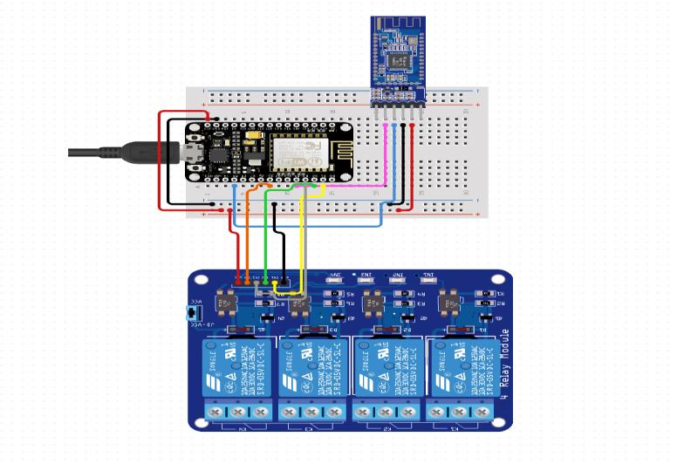

Figure 1: CIRCUIT DIAGRAM

. V. HARDWARE AND SOFTWARE REQUIREMENTS
HARDWARE REQUIREMENTS:
- Raspberry Pi
- PIR Motion Sensor
- LM35 Temperature Sensor
- Relays
- Smart Switches
SOFTWARE REQUIREMENTS:
- Arduino IDE
- HTTP
- MQTT

VI. TECHNOLOGY DESCRIPTION
Python:
Python is a high-level, interpreted programming language known for its simplicity, readability, and versatility. In the context of home automation, Python is widely used for scripting and automating tasks on platforms like the Raspberry Pi. Its extensive libraries and community support make it ideal for integrating sensors, actuators, and communication protocols such as HTTP and MQTT. Python can be used to write scripts that collect data from sensors (like PIR or LM35), control devices via relays or smart switches, and interface with cloud services or voice assistants like Google Assistant and Amazon Alexa. Its compatibility with libraries such as paho-mqtt, gpiozero, and flask enables quick development of lightweight, efficient automation systems, making it a core technology in IoT and smart home applications.
VII. PACKAGES USED
The home automation system leveraging Google Assistant, Alexa, manual switches, and the ESP32 microcontroller typically uses several key software packages to ensure smooth operation and integration. For programming the ESP32, the Arduino Core for ESP32 along with libraries such as WiFi.h and ESPAsyncWebServer are commonly used to enable network connectivity and device control. To integrate voice assistants, the Google Actions SDK, Dialog flow, and Firebase Cloud Functions facilitate Google Assistant commands, while the Alexa Skills Kit (ASK) SDK and AWS Lambda support Alexa voice interactions. Communication between the ESP32 and cloud services often uses MQTT protocol libraries like PubSubClient, with Mosquito serving as a common MQTT broker. Manual switches are managed through ESP32’s GPIO control using standard Arduino libraries, sometimes enhanced by debounce libraries such as Bounce2 to ensure reliable input reading. Additionally, libraries like Arduino Json are employed for data formatting and parsing between devices and services. Together, these packages provide a robust foundation for flexible, efficient, and user-friendly home automation.

VIII. ALGORITHM
Initialize System
- Configure ESP32 GPIO pins for manual switches and connected appliances (e.g., lights, fans).
- Connect ESP32 to WiFi using stored credentials.
- Initialize MQTT client and connect to the MQTT broker.
- Set up communication protocols for Google Assistant and Alexa integration (via cloud backend or direct API).
Monitor Inputs
- Continuously check the state of manual switches (using interrupts or polling).
- Listen for incoming MQTT messages from Google Assistant and Alexa via cloud services.
- Process incoming voice commands received through backend or direct messages.
Process Commands
- When a manual switch state changes, toggle the corresponding appliance state.
- When an MQTT message (voice command) is received, parse the message to determine the intended device and action (ON/OFF).
- Update the appliance state accordingly.
Update State
- Control the appliance (e.g., turn light ON/OFF) by setting the appropriate GPIO pins.
- Publish the updated device state back to MQTT broker to sync with the cloud and voice assistants.
Feedback & Synchronization
- Send device status updates to the cloud (Google Home Graph, Alexa Smart Home API) to reflect current state.
- Optionally, provide local feedback via LEDs or an LCD display.
Error Handling
- Reconnect WiFi if the connection drops.
- Reconnect to MQTT broker if disconnected.
- Debounce manual switch inputs to avoid false triggers.

Repeat
- Continuously loop through monitoring inputs and processing commands to maintain real-time control.

IX SAMPLE CODE
// Smart Home Automation - Arduino Only
// Components: LM35, Button for presence, 3 LEDs

const int tempPin = A0; // LM35 sensor output to A0
const int presencePin = 2; // Button simulating presence detection

const int lightLed = 8; // Light LED pin
const int fanLed = 9; // Fan LED pin
const int climateLed = 10; // Climate control LED pin

// Thresholds
const float TEMP_HIGH = 28.0; // Degrees Celsius - Cooling above this
const float TEMP_LOW = 20.0; // Degrees Celsius - Heating below this

void setup() {
pinMode(tempPin, INPUT);
pinMode(presencePin, INPUT_PULLUP); // Button connected between Pin 2 and GND

pinMode(lightLed, OUTPUT);
pinMode(fanLed, OUTPUT);
pinMode(climateLed, OUTPUT);

Serial.begin(9600); // Optional: Serial monitor for debugging
}

void loop() {
// Read presence
int presence = digitalRead(presencePin);
// LOW = person detected

// Read temperature

int tempReading = analogRead(tempPin);
float voltage = tempReading * (5.0 / 1023.0);
float temperatureC = voltage * 100.0; // LM35 gives 10mV per °C

// Control devices based on readings
if (presence == LOW) {
digitalWrite(lightLed, HIGH); // Light ON

if (temperatureC > TEMP_HIGH) {
digitalWrite(fanLed, HIGH); // Fan ON
digitalWrite(climateLed, HIGH); // Cooling ON
}
else if (temperatureC < TEMP_LOW) {
digitalWrite(fanLed, LOW); // Fan OFF
digitalWrite(climateLed, HIGH); // Heating ON
}
else {
digitalWrite(fanLed, LOW); // Fan OFF
digitalWrite(climateLed, LOW); // Climate OFF
}
}
else {
// No one is present
digitalWrite(lightLed, LOW); // Light OFF
digitalWrite(fanLed, LOW); // Fan OFF
digitalWrite(climateLed, LOW); // Climate OFF
}

// Debugging output
Serial.print("Temperature: ");
Serial.print(temperatureC);
Serial.print(" °C, Presence: ");
Serial.println(presence == LOW? "Yes”: "No");

delay(1000); // 1 second delay
}

X OUTPUT DIAGRAMS:
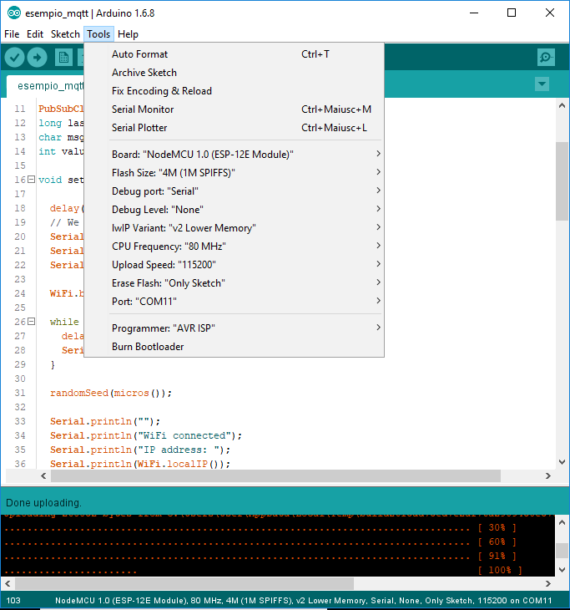
Figure 2: Initialization
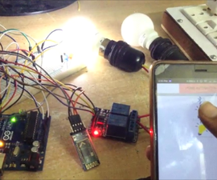

Figure 3: OUTPUT

XI. TESTING
Testing is a crucial phase to ensure that the home automation system works reliably with voice assistants, manual switches, and the ESP32 microcontroller. The following testing steps should be performed:
- Unit Testing
Test individual components separately, such as:
    - Verify ESP32 connectivity to WiFi.
    - Test manual switches by checking if pressing toggles the correct GPIO pin state.
    - Validate MQTT communication by publishing and subscribing to test topics.
    - Test responses from Google Assistant and Alexa through their respective simulators or developer consoles.
- Integration Testing
  - Confirm that the ESP32 properly receives commands from both voice assistants.
  - Check that manual switch actions and voice commands update the device state consistently.
  - Verify synchronization between the device state on the ESP32 and the cloud (Google Home Graph, Alexa Smart Home API).
- Functional Testing
  - Test real-world scenarios such as turning appliances ON and OFF via:
    - Voice commands to Google Assistant and Alexa.
    - Manual switch toggling.
  - Observe if devices respond accurately and promptly.

- Stress Testing
  - Simulate rapid switching of manual switches and repeated voice commands to check system stability.
  - Test WiFi and MQTT reconnect logic by temporarily disconnecting and reconnecting the network.
- User Acceptance Testing
  - Have end users test the system for ease of use, responsiveness, and reliability.
  - Gather feedback on user experience and make necessary adjustments.
- Error Handling Testing
  - Verify that the system recovers gracefully from errors such as lost WiFi connection or failed MQTT publishing.
  - Ensure manual switches still function during cloud or voice assistant outages

XII. CONCLUSION
The implementation of a home automation system using Google Assistant, Alexa, manual switches, and the ESP32 microcontroller successfully demonstrates how modern technologies can be combined to create an efficient, flexible, and user-centric smart home environment. This system enhances convenience by allowing users to control household appliances through multiple interfaces—voice commands via popular digital assistants and physical manual switches—catering to various user preferences and scenarios.
Integrating voice control simplifies everyday tasks, especially benefiting individuals with mobility impairments or those seeking hands-free operation. Meanwhile, manual switches provide a dependable fallback, ensuring that control remains uninterrupted during network outages or voice assistant failures. The ESP32 microcontroller serves as a powerful and cost-effective hub, bridging local device control with cloud-based voice services through secure WiFi and MQTT communication protocols.
Moreover, this approach highlights the importance of interoperability between different platforms and hardware, promoting an inclusive ecosystem that can evolve with user needs and emerging technologies. The modular nature of the system allows easy scalability and customization, enabling users to add or modify devices without extensive reprogramming.
Overall, the project underscores the potential of combining IoT devices with voice assistant technologies to redefine home automation, making living spaces smarter, safer, and more adaptable to modern lifestyles. Future enhancements could include incorporating advanced AI for predictive automation, expanding device compatibility, and improving security features to protect user privacy and data.

XIII. REFERENCES

- Espressif Systems, ESP32 Technical Reference Manual, https://www.espressif.com/en/products/socs/esp32

- Arduino, Arduino Core for ESP32, https://github.com/espressif/arduino-esp32
- Google Developers, Google Actions SDK and Dialogflow, https://developers.google.com/assistant
- Amazon Developer Services, Alexa Skills Kit (ASK)Documentation, https://developer.amazon.com/en-US/alexa/alexa-skills-kit
- HiveMQ, MQTT Protocol Overview, https://www.hivemq.com/mqtt-protocol/
- Simon Monk, Programming the ESP32, McGraw-Hill Education, 2018.
- ArduinoJson Library, https://arduinojson.org/

